The Tallest Skyscraper in the World:
Burj Khalifa
Author: Cayden Zayne Abu-Arja
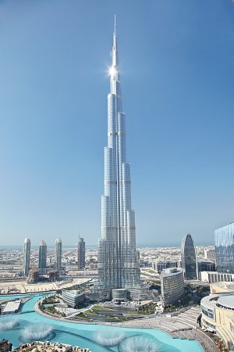

Table of Contents

Teachers Lesson Plan
Overview and Purpose
Length of Activity
Lesson Procedure
Student Age and Placement
Performance Objectives and Target Skill Development

Teacher Guide for Lesson I
Lesson I Important Information from Assigned Icons
Petroleum
First Oil Well Dammam No. 7
Waterway Canals
Suez Canal
Strait of Hormuz
Bab al Mandab

Teacher Guide for Lesson II
Lesson II Important Information from Assigned Icons
Burj Khalifa
Super Tankers
Container Ships
Global Position System (GPS)
Intercontinental Air Travel
Wootz Steel
Silver

Lesson III Presentation
Students' Guide
Middle East Map
Word Search
Crossword Puzzle
Multiple Choice Quiz
Presentation Rubric

Works Cited

Teachers Lesson Plan

- Overview and Purpose
This lesson plan aims to educate students on how The United Arab Emirates (UAE) became home to the record-breaking architectural structure, the "Burj Khalifa." This remarkable tower, the tallest building in the world, is the result of 20th century globalization, technological advancements, manufactured merchandise, political partnerships, efficient usage of transportation canals and economic wealth in the Indian Ocean Region. The lesson plan is an exploration of how the discovery of boiling black goo in the deserts of Arabia, i.e. oil, (in addition to state of the art international discoveries, inventions and advancements) led to the creation of the tallest skyscraper in the world. This lesson teaches students about the evolution of the modern Middle East. It explores the connection between oil production, revenue and architectural endeavors by demonstrating how the UAE came to the forefront of the architectural world by building the luxurious Burj Khalifa. Students will learn how globalization in the Indian Ocean and developments in the Middle East, contributed to building the Burj. The lesson is divided into three sections; the first part focuses on Middle Eastern history prior to the Burj. The second section contains information about how the Indian Ocean Region contributed to the construction of the Burj in terms of technological innovations, transportation advancement and construction material developments. The last portion of the lesson challenges the students to take the knowledge they have learned and utilize it to research one icon from the lesson in depth. Students will need to prepare a presentation that explores the icon's history, its' contribution to building the Burj and its significance in today's world.

- Length of Activity:
This lesson should take three 50-minute class periods, complemented by at home readings, which should be completed prior to the lesson. Students will also need to work on their class presentations outside of class.

- Student Age and Placement
This lesson is suitable for students in middle school and high school. The lesson would work well as part of AP World History or AP Geography.

- Performance Objective and Target Skills Enhancement:
- To gain knowledge about Middle Eastern history, development and globalization in the 20th century until the present day.
- To pinpoint what it took to create the tallest skyscraper in the world
- To enhance research, presentation and communication skills.

Teacher Guide for Lesson I
- Before the lesson, inform the students via email of the assigned readings for the first class.
"Hello Students,
In preparation for the next class, please complete the assigned readings before class. They can be found on the Indian Ocean World History website: http://indianoceanhistory.org/Maps.aspx

Here are the steps to efficiently navigate the website to locate the assigned readings:
- Copy the website link above into your search browser
- Press on "Maps" on the blue bar.
- Scroll down and select the "Industrial and Imperial Era, 1770 C.E to 1914" map, in the map look for the following icon and read the information:
  - Suez Canal
- Go back to the previous map page and scroll down to "Twentieth Century and Globalization 1914 C.E to the Present" map, in the map look for the following icon and read the information:
  - Petroleum
  - First Oil Well Dammam No. 7
  - The Strait of Hormuz
  - Bab Al Mandab
Please get comfortable with using the Indian Ocean World History website and be able to navigate the icons in the maps as we will be using them as our primary source of information for the next three lessons."
- Begin the lesson by introducing the lesson plan structure and clarifying what is expected from the student:
This lesson plan aims to educate students on how The United Arab Emirates (UAE) became home to the record-breaking architectural structure, the "Burj Khalifa." This remarkable tower, the tallest building in the world, is the result of 20th century globalization, technological advancements, manufactured merchandise, political partnerships, efficient usage of transportation canals and economic wealth in the Indian Ocean Region. The lesson plan is an exploration of how the discovery of boiling black goo in the deserts of Arabia, i.e. oil, (in addition to state of the art international discoveries, inventions and advancements) led to the creation of the tallest skyscraper in the world. This lesson teaches students about the evolution of the modern Middle East. It explores the connection between oil production, revenue and architectural endeavors by demonstrating how the UAE came to the forefront of the architectural world by building the luxurious Burj Khalifa. Students will learn how globalization in the Indian Ocean and developments in the Middle East, contributed to building the Burj. The lesson is divided into three sections; the first part focuses on Middle Eastern history prior to the Burj. The second section contains information about how the Indian Ocean Region contributed to the construction of the Burj in terms of technological innovations, transportation advancement and construction material developments. The last portion of the lesson challenges the students to take the knowledge they have learned and utilize it to research one icon from the lesson in depth. Students will need to prepare a presentation that explores the icon's history, its' contribution to building the Burj and its significance in today's world.

- Ask if anyone has any questions regarding the lesson plan, if not, specify the plan for the first lesson:

"Today as a class we will discuss Middle Eastern history prior to the Burj's construction in (insert date). We will be able to make connections between the icons and their role in the Burj’s timeline.

Today we will fully discuss the importance of the following icons:

Suez Canal, Petroleum, First Oil Well Dammam No. 7, The Strait of Hormuz, and Bab Al Mandab.

Which are located in three maps from the Indian Ocean World History Website:
- Industrial and Imperial Era, 1770 C.E to 1914
- Twentieth Century and Globalization 1914 C.E to the Present."
- Print out or project a map of the Middle East on the board in front of the entire class and ask the students to pinpoint where the icons are located on the map and begin a class discussion revolved around the readings. (http://www.yourchildlearns.com/online-atlas/middle-east-map.htm)
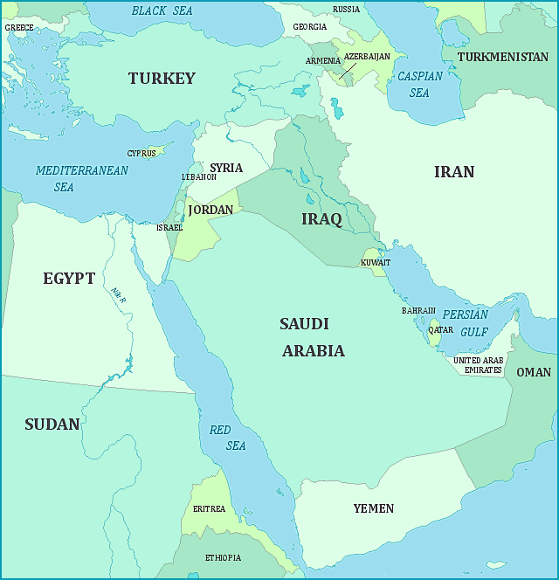

- Split the class into two, one group should research about the discovery of oil using the icons, "Petroleum" and "First Oil Well, Dammam No. 7". The other half will research about waterway canals using the icons "Suez Canal", "Bab Al Mandab" and "The Strait of Hormuz".

Both groups should discuss the importance of these geographical (natural or manmade) landmarks or discoveries in the Middle East. Conduct a debate on which geographical element (waterways or oil) was more beneficial to the Middle East region in terms of environment, economy, and social aspects. Question whether or not the waterways and oil discoveries could be successful without being dependent on each other.

- Team Waterway Canal:
Pros: Increase trade between continents; reduce cost of merchandise, quicker transportation.
Cons: deaths while building the Suez Canal, dangerous Bab Al Mandab

- Team Oil:
Pros: Oil money, booming economy, can fund projects to reflect wealth (such as Burj Khalifa) to attract tourism.
Cons: Oil spills polluting waterway canals. Not environmentally friendly.

- Conclude the lesson by acknowledging both sides of the debate and explain how the discovery of oil boosted finances in the Middle East. It facilitated the establishment of multinational partnerships and fostered trade through waterways to distribute oil worldwide. This trade placed the Middle East, especially Saudi Arabia and the United Arab Emirates, in a position of wealth and power. In turn, it transformed Dubai into the fastest growing city in the world. The tallest building in the world was built as a product of oil discovery and waterway distribution, enhancing globalization in the Indian region and funding 20th century state of the art innovative technology.

- At the end of the lesson, for fun, hand out a word search puzzle for the students to get familiar with the next icons they will be reading about for the next lesson.

Lesson I Important Information from Assigned Icons

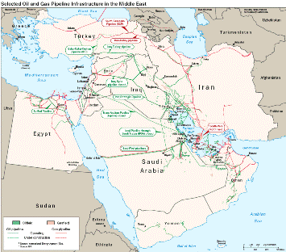
For this lesson, students are expected to read all of the information related to each icon. Below, are selected portions of each icon emphasizing the critical information relevant to the lesson.

Petroleum
Petroleum, or crude oil and its byproducts, have affected the world tremendously in the 20th century. Gasoline and diesel are fuels that power cars. Propane gas is used to heat many homes. Five of the world's largest oil producers are located in the Indian Ocean region. An estimated 40 percent of the world's offshore oil supply also comes from the Indian Ocean. The Indian Ocean shipping lanes are a lifeline for most of the world's national economies. Tens of thousands of barrels of oil are shipped to the United States from the Arabian (Persian) Gulf every month. Gulf oil pipelines are shown in the second image. Petroleum is a 'strategic commodity' because it is so critical to the world economy.

First Oil Well Dammam No. 7
In 1933, Standard Oil of California(SOCAL) was given permission to explore for oil in the Saudi Arabian desert. Geologists surveyed the surface of the country and mapped its features. King Abdul Aziz ibn Saud was founding ruler of the Kingdom of Saudi Arabia in 1925. The king authorized the team to explore and drill, hoping at least to find new sources of water. The SOCAL team, aware of petroleum finds elsewhere in the region, believed they might find oil. The surveys were promising and during the next five years they drilled test holes in various locations. They first struck oil at a well-head named Dammam No. 7 at a depth of 5000 feet. Named the 'Prosperity Well,' Dammam No. 7 produced 32 million barrels of oil during the 45 years it flowed. Saudi Arabia currently has approximately one fifth of the world's known oil reserves.
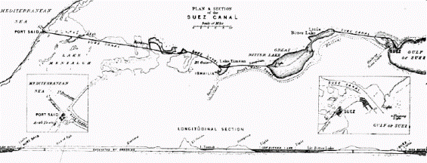
Waterway Canals

Suez Canals
These two satellite images show how the Suez Canal cuts through the short distance between the Mediterranean and the Red Seas. The artificial waterway is 163 km (101 mi) long, running north to south across the Isthmus of Suez in northeastern Egypt. The Suez Canal is one of the most important waterways in the world, and is often called the 'crossroads of Europe, Africa, and Asia' because the route is used to transport goods to and from all three continents. water transport of goods between Europe and Asia was possible without sailing around Africa or traveling overland. This was especially important to European imperial powers with colonies in east Africa and Asia. the canal had an immediate and dramatic effect on world trade. the canal allowed the world to be circled in record time.
The Strait Of Hormuz
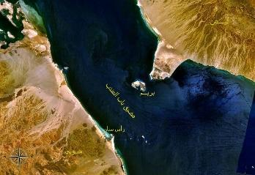
The Strait of Hormuz is a narrow waterway between the Gulf of Oman and the Arabian (Persian) Gulf. Iran is located to the north of the Strait and the Arabian peninsula to the south. The southern coast of the Strait is formed by the Omani peninsula of Musandam. At its narrowest point, ship lanes follow the deeper Omani waters through the Strait, but pass through both Iranian and UAE waters as well. Although these are not international waters, it is in the best interests of all of these countries to keep the Strait open. It is the only sea passage into the Indian Ocean for many of the countries that produce oil in the Arabian (Persian) Gulf. Twenty percent of the world's daily oil supply passes through the Strait of Hormuz on large tanker ships. This makes the Strait a very important strategic and economic location, or "choke point." This means that if oil shipments were stopped, or "choked off" at the Strait it could cause shortages of petroleum products that would impact economies around the world.

Bab Al Mandab
This map shows the Bab al Mandab Strait, which allows ship passage from the Red Sea to the Gulf of Aden, and thus to the Arabian Sea. In Arabic, "Bab al Mandab" means "Gate of Lamentation" and refers to the dangers of passing through the strait. It is only about 20 miles wide, and a small island in the center, called the Island of Perim, divides the strait into two separate channels. The eastern channel is Alexander's Strait, only two miles wide. The western channel is Dact al Mayun, only 16 miles wide. The narrow span of Bab al Mandab makes it very difficult to navigate, and ships must be very careful not to crash into each other if they attempt to cross the strait at the same time. As much of the world's oil comes from the Middle East, ships carrying the oil must often pass through Bab al Mandab on their way to the Suez Canal. If ships had to take a different route, they would spend extra time and money to take oil from the Middle East to Europe and North and South America. Bab al Mandab is a strategic link between the Indian Ocean, the Mediterranean Sea, and the rest of the world.

Teacher Guide for Lesson II
Before the lesson, inform the students via email the expected assigned readings for the first class.
"Hello Students,
In preparation for the next class, please complete the assigned readings before class. They can be found on the Indian Ocean World History website: http://indianoceanhistory.org/Maps.aspx

Here are the steps to efficiently navigate the website to locate the assigned readings:
- Copy the website link above into your search browser
- Press on "Maps" on the blue bar.
- Scroll down and select the "Ancient Era" map, in the map look for the following icon and read the information:
  - Silver
- Go back to the previous map page and scroll down to "Medieval Era" map, in the map look for the following icon and read the information:
  - Wootz Steel
- Go back to the previous map page and scroll down to "Twentieth Century and Globalization 1914 C.E to the Present" map, in the map look for the following icon and read the information:
  - Burj Khalifa
  - Super Tankers
  - Container Ships
  - Intercontinental Air Travel
  - Global Positioning Satellite
  - Communication Satellites
There will be a multiple choice quiz regarded all the icons and readings."
- Specify the plan for the second lesson:

"Today as a class we will discuss how the Indian Ocean Region contributed to the construction of the Burj.

Today we will fully discuss the importance of the following icons:
- Silver, Wootz Steel, Burj Khalifa, Super Tankers, Container Ships, Intercontinental Air Travel, Global Positioning Satellites and Communication Satellites.

Which are located in three maps from the Indian Ocean World History Website:
- Ancient Era
- Medieval Era
- Twentieth Century and Globalization 1914 C.E to the Present"

- Print out or project a map of the Middle East on the board in front of the entire class. Distribute the crossword puzzle to the students, this will test if they can match the descriptions with the icons. Once a student has identified an icon on the crossword puzzle, they can add the icon to the map (continuing on from last lesson's map) and read the icons' description out loud to the class to promote class discussion. Build upon last lesson's icons of oil and waterways and see how this week's icons are intertwined with last week's. Promote a discussion of how the students see connections being made.
4. Individually or in pairs, designate an icon for each student/group to research. Students should focus on the icon's impact, in particular how it affected the development of globalization in the 20th century, with particular attention paid to its impact on the Indian Ocean Region. Students are required to tie specific significance to the Middle East and Burj Khalifa. They should begin to brainstorm for a final presentation for the following class. Students will need to find sources outside of the IOWH website to complete their in-depth icon research. Distribute rubric and assign icons.

Areas of Innovation and Icons:
- Technology: Global Positioning Satellites, Communication Satellites
- Transportation: Intercontinental Air Travel, Super Tankers, Container Ships
- Construction and Architecture: Steel, Silver.
5. For the last 15 minutes of class, hand out the multiple-choice quiz that tests all the material covered in the past two lessons.

Lesson II Important Information from Assigned Icons

For this lesson, students are expected to read all of the information related to each icon. Below, are selected portions of each icon emphasizing the critical information relevant to the lesson.

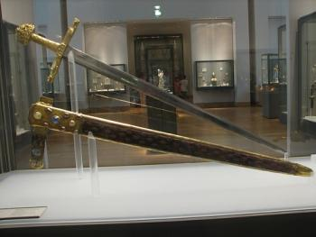
Burj Khalifa Icon also known as "The Khalifa Tower" is the tallest skyscraper in the world! The tower consists of 160 floors and reaches an extraordinary 2,716.5 feet (converted to 828 meters) in height. It is located in Dubai, United Arab Emirates and cost a mighty 1.5 billion US dollars to build. Burj Khalifa is three times as tall as the Eiffel Tower located in Paris and almost double the size of the Empire State Building in New York City. The Burj Khalifa is also the tallest freestanding structure in the world, has the highest number of stories in the world, has the highest occupied floor in the world, has the highest outdoor observation deck in the world, has the elevator with longest travel distance in the world, and has the tallest service elevator in the world. The Indian Ocean region is home to several of the world's tallest buildings. Others in the region include the Abraj Al-Bait Towers in Saudi Arabia (also the world's largest clock face); Taipei 101 in Taiwan; the Shanghai World Financial Center in China; and the Petronas Towers in Malaysia

Construction Materials
Wootz Steel: Medieval Era
To make steel, metalworkers developed special methods for producing pieces of carbonized iron, adding certain materials to the recipe, heating the iron and fusing it with carbon particles. Indian metalworkers produced blocks of steel that were exported to Persia, and later to Damascus, where they were worked into fine blades. Steel blocks from India were a regular trade good on the monsoon routes, being also mentioned in the Geniza Documents of Cairo.
Silver: Ancient Era
Found by archeologists buried inside a tomb at the Royal Cemetery of Ur, it dates from about 2600-2400 BCE. Silver was an important trade good during the Ancient Era, desired by the wealthy for use in art and jewelry. Found primarily in Anatolia, it was exported from this region to Mesopotamia by Assyrian merchants living in trading colonies. European merchants transported silver to the Indian Ocean, where it could be exchanged for Indian and Chinese goods.

Transportation
Super Tankers 21:00
In the 1800's, petroleum was often shipped in leaky wooden barrels onboard normal shipping vessels. Later, ships were designed with large, water-tight tanks inside the hulls below deck. Today, most of these ships are enormous supertankers as long as 1,300 feet and capable of carrying hundreds of thousands of tons of petroleum products. More than two billion tons of oil move across the world's oceans each year. They are carried by oil tankers, huge ships that can carry millions of barrels of oil on each journey. There are different types of ships used to transport oil. "Crude tankers" are large and transport bulk quantities of unrefined crude oil from oil wells where it is extracted to refineries where it is turned into gasoline, plastics and other products. "Product tankers" are smaller and carry petrochemicals such as gasoline from refineries to ports where people take the products inland. The biggest tankers can carry over three million barrels of oil at a time. These ships are so big that they generally cannot enter ports. They usually unload their cargo at off-shore platforms or onto smaller tankers. Oil and its byproducts are strategic commodities, vital to the world's economy. In the Strait of Hormuz, through which 20% of the world's daily oil supply passes from the Arabian (Persian) Gulf, there are many security precautions to ensure that supertankers can move the world's oil supply safely.
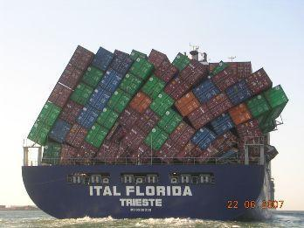
Container Ships
These freight trains of the oceans are vital to international trade. Originally, container ships were converted tanker ships. Container ships are built as large as possible to carry cargo efficiently. The biggest possible size of container ships is limited by the geography of two choke points of the Indian Ocean. One size limit is called the Suez maximum standard. The maximum size of a ship passing through the Suez Canal is 400 meters long and just over 50 meters wide. The other size limit is called the Malacca Max standard, about 470 meters long and 60 meters wide. Ships of this size are the largest capable of fitting through the Strait of Malacca. These standards also include the "draft" of the ship, or how deep into the water it goes without nearing the bottom of the strait or canal. A container is a rectangular or cube-shaped metal box with doors on one end. It is designed to move cargo from one kind of transportation to another without unpacking. Containers travel around the globe many times over, used and reused. Container shipping has revolutionized the global economy. In the twentieth century, standard shapes and sizes for containers were developed gradually. The first standard sized shipping containers came into use in 1956. Today, nearly every product you can buy has traveled long distances in a shipping container. Companies can employ factory workers wherever wages are lowest. They can ship the materials to the factory, and the goods to consumers in containers. This has led to global manufacturing of all kinds of products, but it has led to a decline in manufacturing in some of the older manufacturing countries like Europe and the United States.
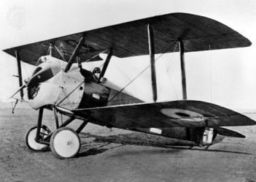
Intercontinental Air Travel
Jet powered aircraft have also made international travel widely available, affordable and convenient for people all over the world. Massive global movements of people such as the annual pilgrimage to Makkah in Saudi Arabia, migrant labor, and international business between the United States, the Middle East and Asia could not happen without intercontinental air travel.

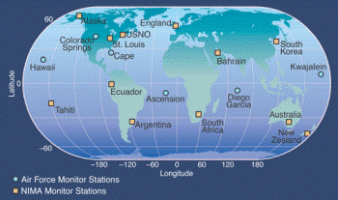
Technology
Global Positioning Satellite (GPS)
The Global Positioning System, or GPS, is a way of using fine coordinates to locate anything on earth's surface, based on latitude and longitude as measurements. Because the earth is a sphere, it can be divided into 360 degrees around the equator E to W, and 360 degrees around the prime meridian N to S. Businesses and individuals also benefit greatly from the system. Because the receivers are so accurate, they are a major part of global shipping operations. Companies can track the locations of packages or cargo being shipped globally, or find their ships as they travel the earth's oceans.
Communication Satellites
Early satellites were developed and launched in the late 1950s and early 1960s, providing telephone and television services that previously required cable lines. The first satellite provider to expand coverage to the Indian Ocean region was the International Telecommunications Satellite Organization (INTELSAT) A maritime communications company, Inmarsat, recently launched a broadband network to provide internet, phone, and GPS communication to commercial and leisure ships anywhere on the Indian Ocean. Many companies like these have created satellite networks to provide television, mobile phone service, and internet access to areas too remote for landlines.

Teacher Guide for Lesson III
1. Before the lesson inform the students what to expect for the next class, attach rubric to email.

"Hello Students,

Students should focus on the icon's impact, in particular how it affected the development of globalization in the 20th century, with particular attention paid to its impact on the Indian Ocean Region. Students are required to tie specific significance to the Middle East and Burj Khalifa. In class everyone was assigned a specific icon listed below:

Areas of Innovation and Icons:
- Technology: Global Positioning Satellites, Communication Satellites
- Transportation: Intercontinental Air Travel, Super Tankers, Container Ships
- Construction and Architecture: Steel, Silver.
There are no assigned readings for the following class. Instead, please work on your final presentation. Please be sure that your presentation satisfies all the criteria on the rubric to the best of your ability and be sure your research explores the icon's history in depth to elucidate both its significance and its significance towards the construction of the Burj."

2. During class period, have students share their presentations in chronological order, starting with icons from the Ancient Era. Students must peer review their classmates and grading will be based on the rubric.

3.To conclude class, read the Burj icon together and reflect as a class on what was learnt and answer any questions that remain.

LESSON I & II
Name: ____________ Middle East Map Date: _____________

LESSON I

Name: ____________ Word Search Date: _____________
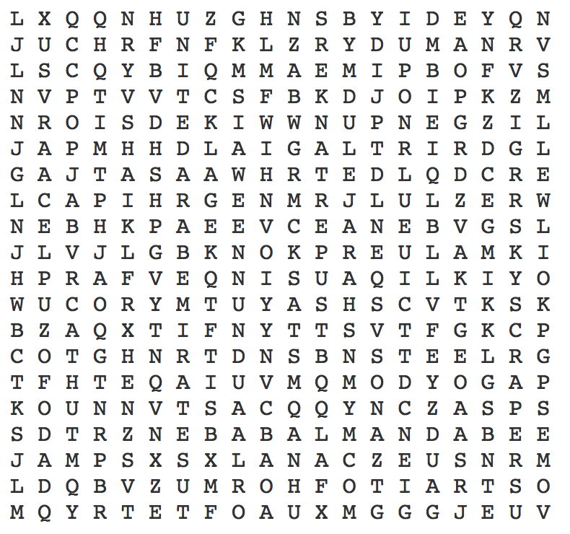
The Burj Khalifa

AIR TRAVEL  BAB AL MANDAB  BURJ KHALIFA  CONTAINER SHIPS  DUBAI  GPS  INTERCONTINENTAL  MIDDLE EAST | OIL WELL  SILVER  SKYSCRAPER  STEEL  STRAIT OF HORMUZ  SUEZ CANAL  SUPER TANKERS  UNITED ARAB EMIRATES

LESSON II
Name: ____________ Cross Word Puzzle Date: _____________

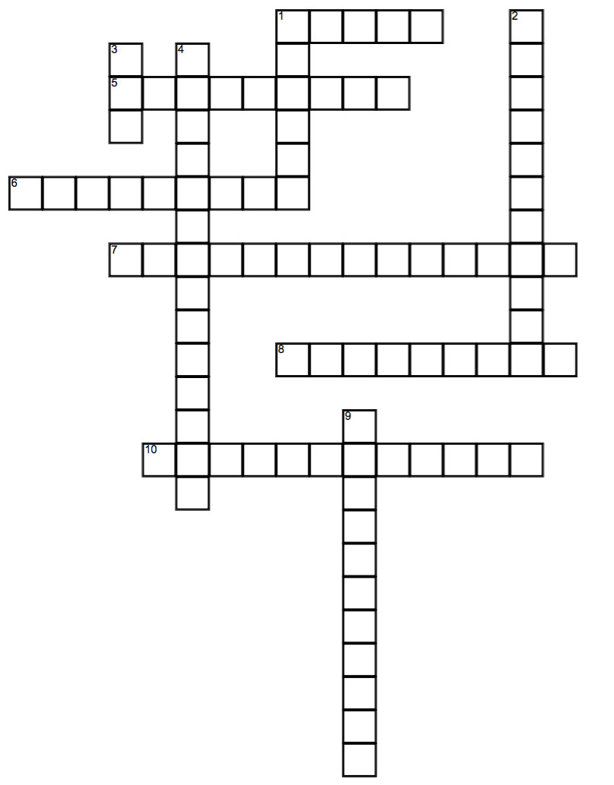

LESSON II
Name: ___________ Cross Word Puzzle Date: _____________

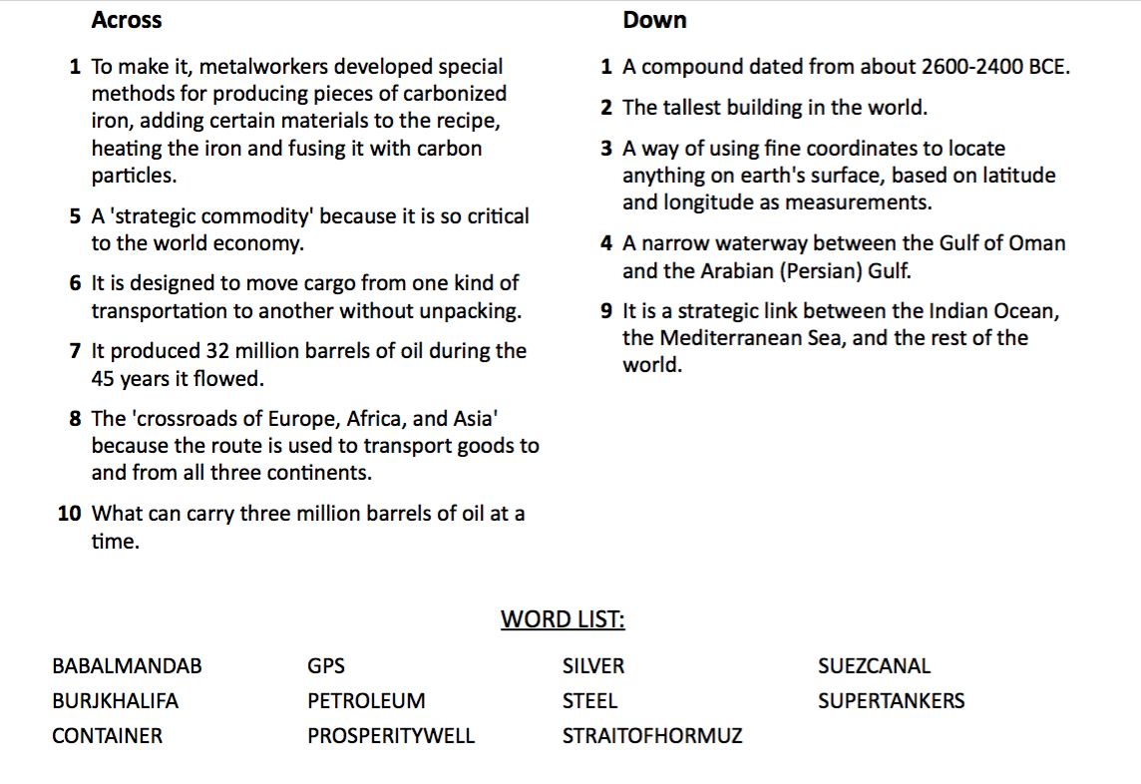

LESSON II
Name: _____________ Multiple Choice Quiz Date: _____________

To the best of your abilities, using your gained knowledge from the readings, please answer the questions below by circling one of the three multiple choice answers you believe is correct.

- Which waterway transportation canal was man made?
- Bab Al Mandab
- Strait of Hormuz
- Suez Canal
- Where is Burj Khalifa located in the Middle East?
- United Arab Emirates
- Saudi
- Iran
- How many barrels of oil are shipped to the United States from the Arabian Gulf monthly?
- Thousands
- Tens of Thousands
- Hundred of Thousands
- An estimated ___ of the worlds' offshore oil supply from the Indian Ocean.
- 20%
- 40%
- 60%
- What year was the Standard Oil of California given permission to explore the oil in the Saudi Arabian desert?
- 1914
- 1929
- 1933
- Who was the founding ruler of the Kingdom of Saudi Arabia in 1925?
- King Hussein Bin Talal
- King Abdul Aziz ibn Saud
- King Hamad bin Isa Al Khalifa
- What did the King of Saud initially intend to find before stumbling upon oil?
- Silver
- Gold
- Water
- Which well was the key to finding the largest supply of crude oil, or petroleum, in the world?
- Dammam No. 4
- Dammam No. 7
- Dammam No. 1
- How many barrels of oil did the "Prosperity Well" produce in its' 45 years it flowed?
- 16 million
- 24 million
- 32 million
- Since when is has Silver been discovered?
- 2600-2400 BCE
- 1200-1000 BCE
- 3400-3200 BCE
- What element required metalworkers to develop special methods for producing pieces of carbonized iron, adding certain materials to the recipe, heating the iron and fusing it with carbon particles?
- Copper
- Steel
- Silver
- When were the first satellites developed and launched?
- Late 1940's – early 1950's
- Late 1950's – early 1960's
- Late 1960's – early 1970's
- What is GPS able to locate objects on the earth's surface through?
- Using fine coordinates of latitude and longitude as measurements
- Using tidal wave lengths of the ocean
- Using meteorological predictions

Teachers' Answer Sheet
Burj Khalifa Multiple Choice Quiz

      - C
      - A
      - B
      - B
      - C
      - B
      - C
      - B
      - C
      - A
      - B
      - B
      - A

LESSON III
Name: ___________ Presentation and Debate Date: _____________
The Burj Khalifa

INSTRUCTIONS:
Prepare a presentation regarding an icon for the Indian Ocean World History website maps we have studied in the past two lessons and research in depth its significance and impact to the creation of the Burj. This will require sources outside of the IOWH website to supplement the material in the icons.

ICONS TO CHOOSE FROM:

INTERCONTINENTAL AIR TRAVEL
BAB AL MANDAB
BURJ KHALIFA
CONTAINER SHIPS
GPS
OIL WELL
SILVER
STEEL
STRAIT OF HORMUZ
SUEZ CANAL
SUPER TANKERS
COMMUNICATION SATELLITES

During class period, have students share their presentations in chronological order, starting with icons from the Ancient Era. Students must peer review their classmates and grading will be based on the rubric. Each presentation should be three to five minutes long.

To conclude class, we will read the Burj icon together and reflect as a class on what was learnt, establish a discussion and answer any questions that remain, such as:

- How did the development of technology permit Dubai to build a record breaking building?
- How significant was the discovery of oil to the Middle Eastern economy?
- How important were the waterways for Middle Eastern trade?
- Explain how the Burj may be a symbol of the modern Middle East?
- What bigger connections can we make to predict the future by studying the history of the chosen icons?

RUBRIC AND CRITERIA FOR PRESENTATION

 | 1 | 2 | 3 | 4 | 5
 | Poor | Satisfactory | Good | Great | Excellent
Presentation and communication skills
In depth research of the Indian Ocean Region
Information and knowledge upon subject
Contribution to class and group work
Relevant connection to the Burj
Time Management (between 3-5 minutes
Final Grade

Works Cited

DC WEb Designers (410)740-9181, www.dcwebdesigners.com. "Our Maps." Indian Ocean in World History | Maps, indianoceanhistory.org/Maps.aspx.

Dubai, fam Properties. "How They Build the World's Tallest Building Burj Khalifa - Construction Documentary." YouTube, YouTube, 17 Apr. 2016, www.youtube.com/watch?v=12oynGTjYKs.

Luxeadventuretraveler. "10 Fun Facts about the Burj Khalifa." Luxe Adventure Traveler, 30 Nov. 2018, luxeadventuretraveler.com/fun-facts-about-the-burj-khalifa/.

Taylor, Jerome. "Map of the Middle East." Map of the Middle East, www.yourchildlearns.com/online-atlas/middle-east-map.htm.

